

**American International University- Bangladesh**

**CSC 3215: Web Technologies**

**CO1 and CO3 Evaluation**

**Project Report**

**Spring 2019-2020**

**Group No: 1**

**Project Title: Tailor Management System**

|  |  |
| --- | --- |
| Student Name | Student Id |
| Nahar, Naznin | **18-37454-1** |
| Kabir, Daiyan | **18-37507-1** |
| Uddin, Farhan Sakib | **18-37509-1** |

**Introduction:**

Finding a good & reliable tailor to get desired designed, measured dress is a very difficult and hassling task**.**

Using this software customer can find tailor and give orders for custom made dresses as they wish. Finally the dress will be delivered to the specific customer after the job is done.

**Background study:**

***Available solution*:**

* Alter the wrong designed dress again
* Find nearby tailor shop
* Fix price with the tailors
* Purchase readymade dress online

***The Solution:***

* Order online through software (mobile app/website)
* Order through phone calls
* We will work as an intermediary here between the customers and tailors to help them get or give orders and find tailors in the customer’s current location for ease.

**User Category:**

There are three types of Users here. They are:

* Admin
* Customer
* Tailor

**Feature List:**

In this project the “User Type 1” has the following features:

* Can see order information
* Can see delivery information
* Can add, update, delete users and employee

In this project the “User Type 2” has the following features:

* Can log into the system
* Can order dress to a specific tailor
* Can see which employee will deliver the dress
* Can see the information of employee provided by admin

In this project the “User Type 3” has the following features:

* Tailors can take order
* Confirm order
* Can see order information
* Can see delivery information

**GUI Description:**

1. **Login:** When users or admin will enter in the tailor management system they will see these admin login and user login.

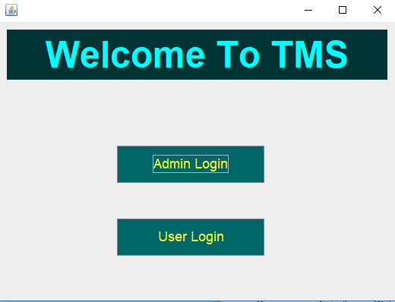

1. **Admin Login:** Admin can log into the system by giving user id and password. Both admin and users can log into the system respectively.

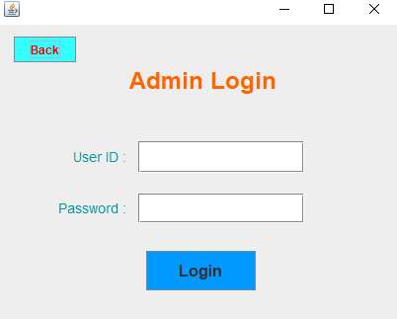

1. **Admin profile:** After logging in successfully admin will be presented with these options where he/she can see order information, delivery information and also delete user and employee.

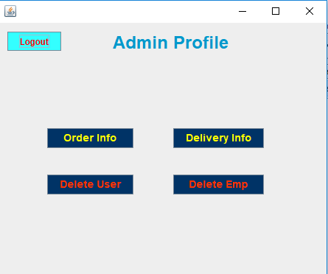

1. **Register:** New users have to register before he/she can log into the system. By clicking new user, a register form will be provided for necessary information collection.

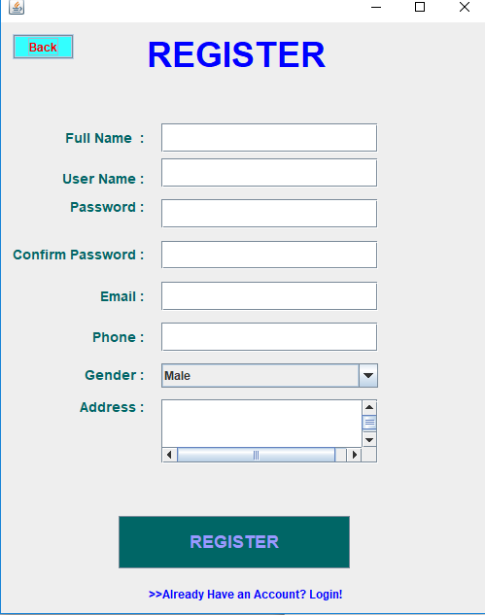

**Database Table Description:**

4 Tables have been used in this project they are admin, customer, employee and tailor.

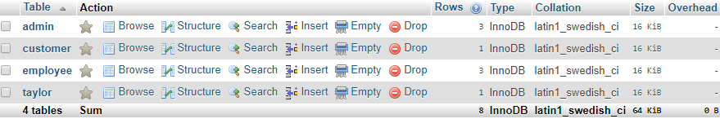

1. Admin table where username and password are the attributes.

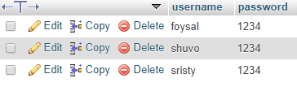

2. Employee table where name, id, email, phone and gender are the attributes.

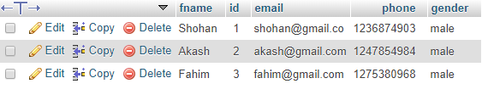

**Use case Diagram:**

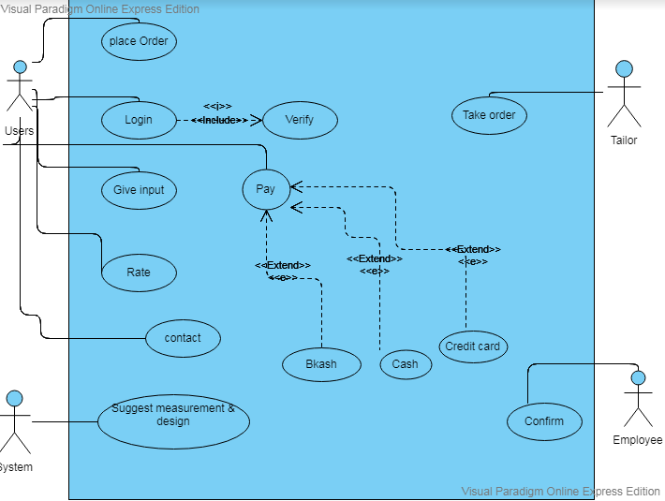

* In a tailor management system a client can order dresses. He/she needs to login to the system as a user. User can input dress type, design, measurements and quantity. The system will suggest proper measurements and design to the user. After placing the order, a tailor will take that order based on the location. The tailor will prepare the dress. An employee of the tailor shop will collect the fabric and other items necessary for the dress from user address. The user can pay by cash, Bkash or credit card. If any error happens, the user can contact with the tailor within seven days with proper measurements. Users can also rate the tailors. There will be a verification system for the regular users to get discount or offer. After placing the order of dress, an employee will confirm the delivery date and time.

**Class Diagram:**

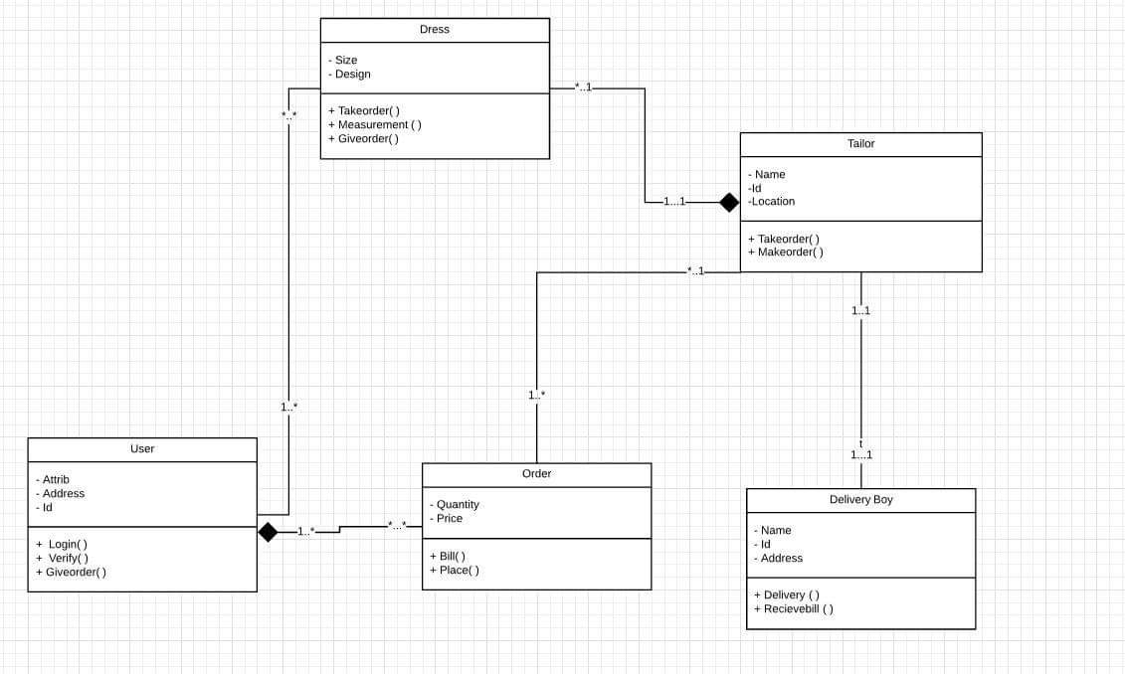

* A user can order one or more dresses.
* A tailor will prepare one or more dresses. Order will be placed for limited time.
* One user can place multiple orders.
* One tailor can take many orders.
* Dresses will be delivered by delivery boy.
* After receiving the order, the user will pay the bill.

**Activity Case:**

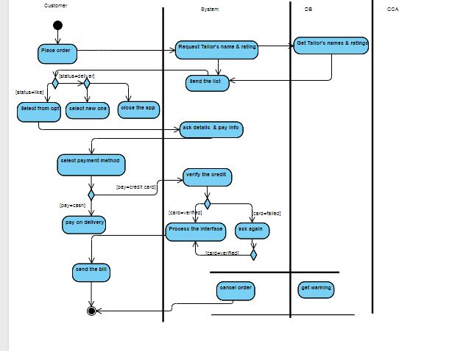

Figure: 03

In an online tailor management system, a customer places order to the system selecting the dress design and size. The system then gets the entire tailors name in the customer’s location and ratings from the database. Once the tailor's name and their ratings are received, the system displays the option of the tailor's name and the schedules of returning dress to the customer. If the customers like any of these options, she/he selects the option. But, if they don't like the tailors, they can change and select new one or she/he can close the application. After selecting an option, the system asks for customer details and payment information. If the customer pays by credit card, then the system verifies the credit card. If the credit card is valid, the system writes all the orders information in the database and sends customer information to the tailors simultaneously. If the verification of the credit card fails, the system sends an error message to the customer and request for the card information again. The verification process is done again. If the credit card verification fails for three times the system cancels the ordering process and sends a warning message to the credit card agent at the same time. Once the ordering is done the system passes the message to the interface generates a bill and sends it to the customer.

**Sequence Diagram:**

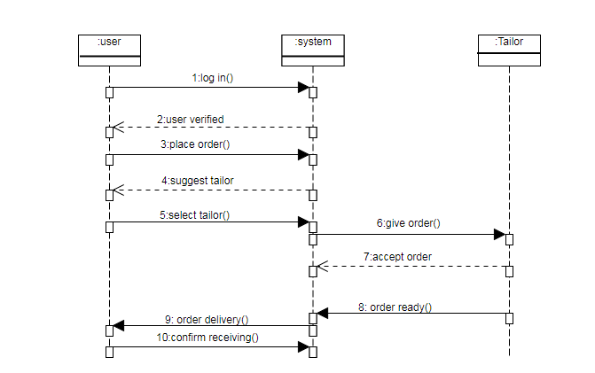

* In a tailor management system a user logs into the management system. The management system verifies the user authentication using the information provided in user account. After successful verification the user places a dress order with measurements in the management system. Then the management system suggests some tailors' information’s near the user's location. Then the user selects a tailor. The management system gives the order to the selected tailor. After preparing the dress, the tailor confirms in the system. After completing the order, the management system informs the user about the delivery. After receiving the dress, the user confirms the delivery and rate the tailor's work.

**Tools Used:**

To develop this project we have used the following:

* CSS
* Html5
* Notepad++
* Xampp

**OOP and PHP Concepts Used:**

* Encapsulation: Package Tailor management system
* Polymorphism:
* Abstraction:
* Inheritance:

**Impact of this Project:**

What impact this project will have on the society and economy?

Many unemployed people can get job from here, as there are many customers and to fulfill their orders we need more tailors. So people can do part time job here. It is a high demand project tailors can be benefitted from here which will have some impact on our economy. For society it will solve unemployment problem.

How will people be benefitted from your project?

By using these –

* Customer can save their time
* Customer will not have any trouble to give order and take dress from tailors.
* Customers can purchase custom made dress.
* Best quality will be provided.

**Limitations and Possible Future Improvements:**

* 1. Problems may arise in the time of taking dress’s measurement, and design perfectly.
  2. Tailors may be late sometimes for their tight schedule or in the occasions.
  3. Tracking locations would not be easier.
  4. Technical error like performance of the software may arise.